Triangular Bipyramid

Definition
# Source: AI Source: Provided by: [Data Path: Persons Table -> ID Column: 1, Name_En Column: Motasem Essam] -> From: [ChatGPT] on [7/25/2026]
A Triangular Bipyramid is a convex polyhedron formed by joining two triangular pyramids along a common triangular base, with their apexes positioned on opposite sides of the shared base.
It consists of 6 triangular faces, 9 edges, and 5 vertices.
When the two pyramids are congruent and arranged symmetrically, the solid has a threefold rotational symmetry axis.

Simple Definition
# Source: AI Source: Provided by: [Data Path: Persons Table -> ID Column: 1, Name_En Column: Motasem Essam] -> From: [ChatGPT] on [7/25/2026]
A triangular bipyramid is a three-dimensional solid formed by joining two triangular pyramids base-to-base, creating two opposite apexes and three triangular vertices around the middle.
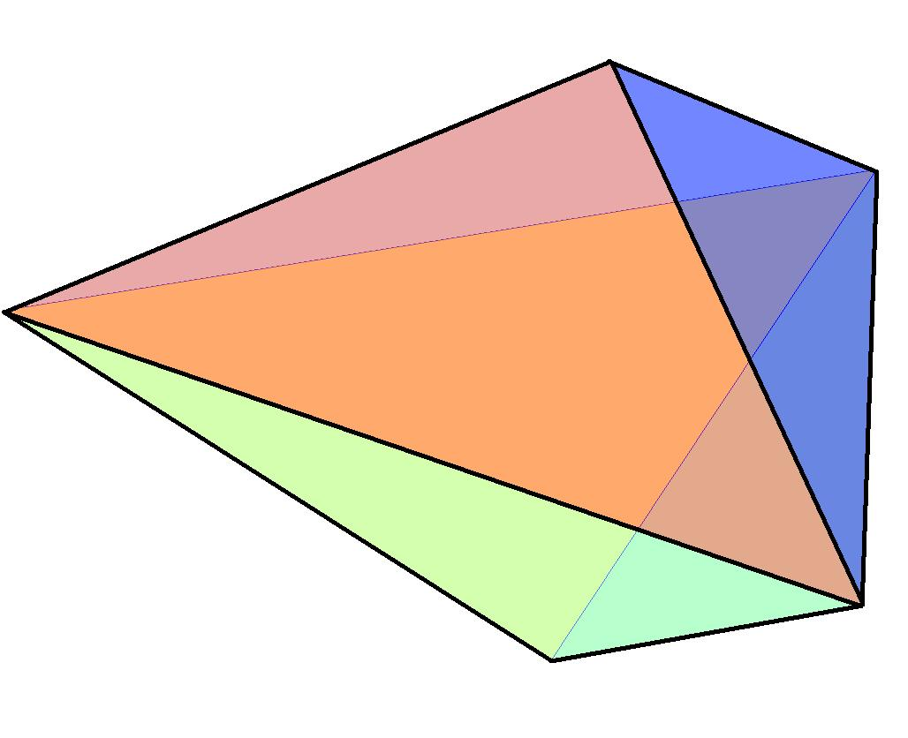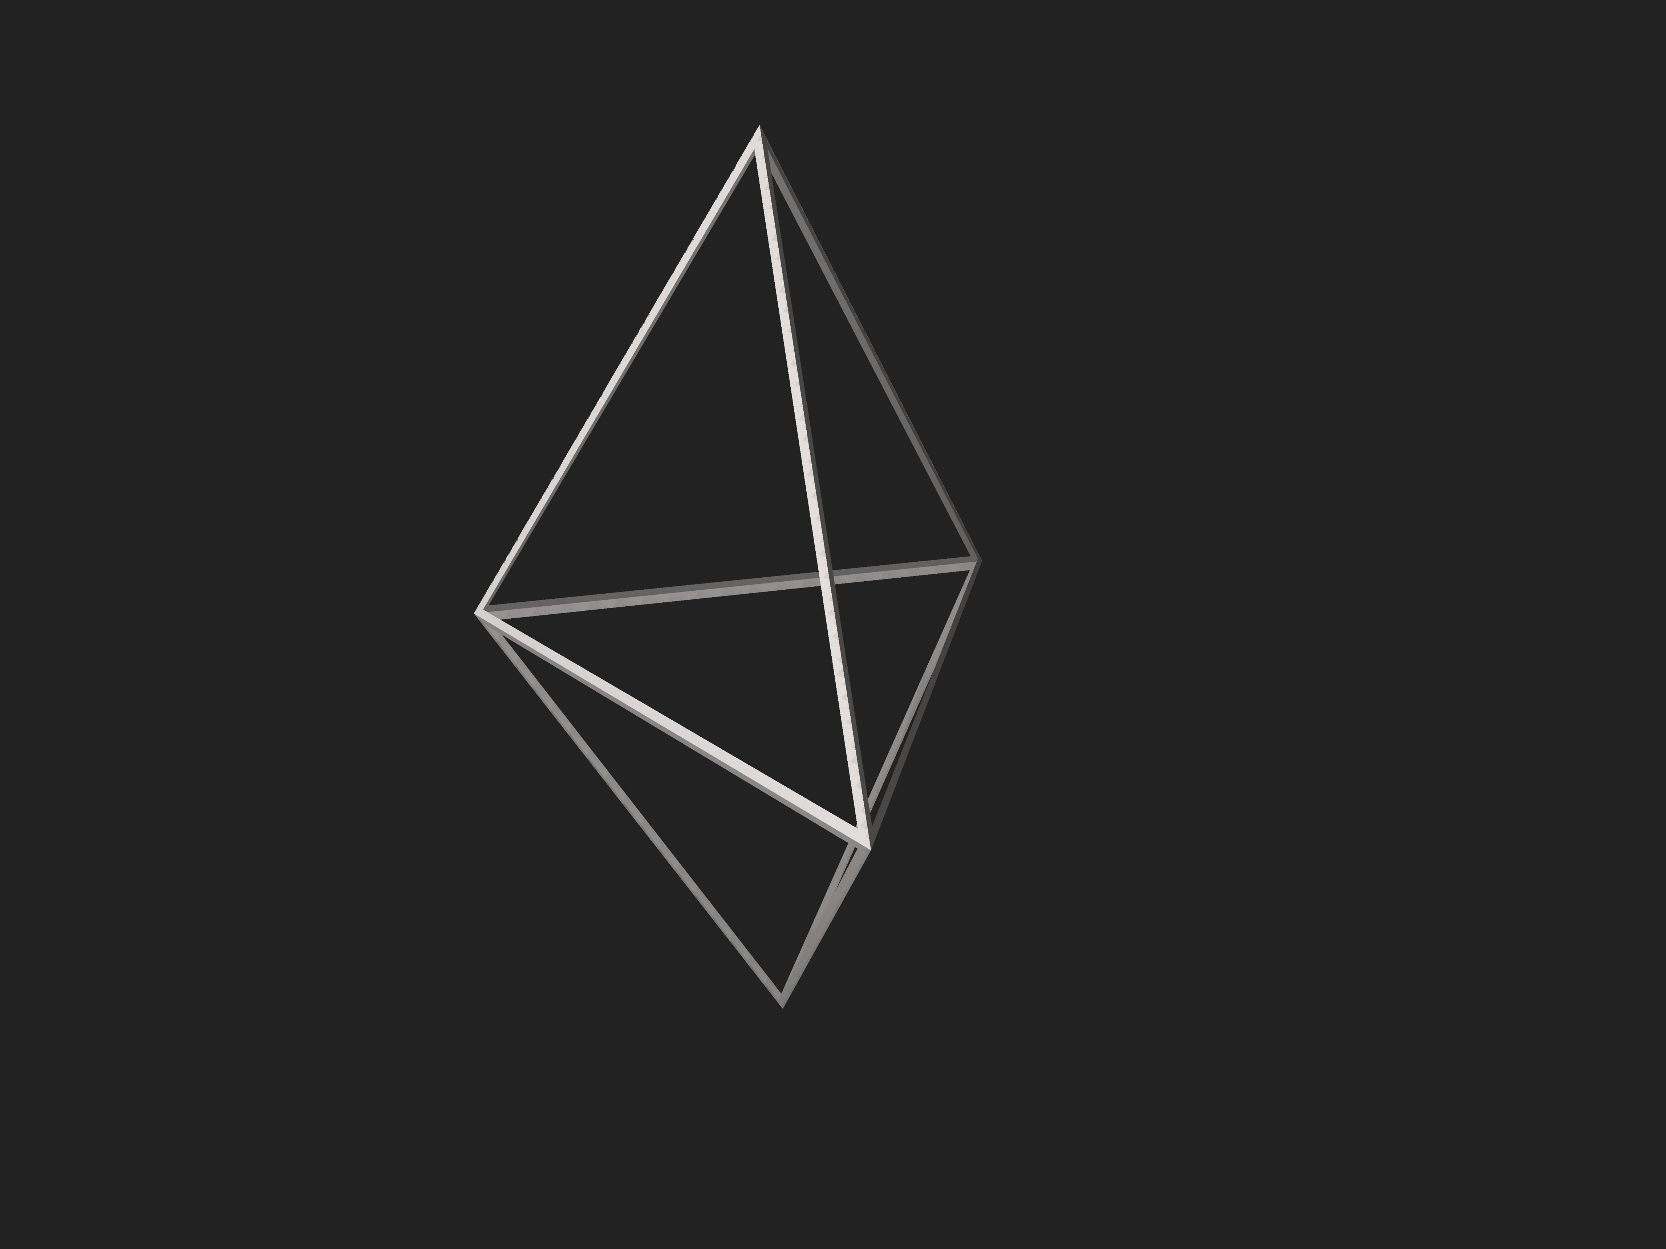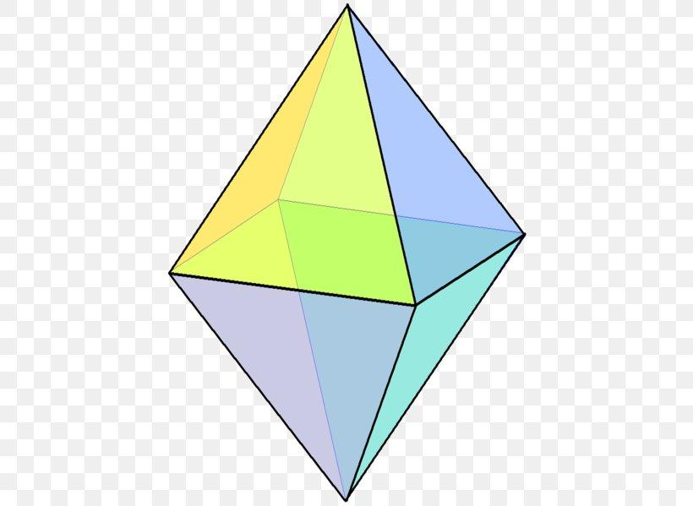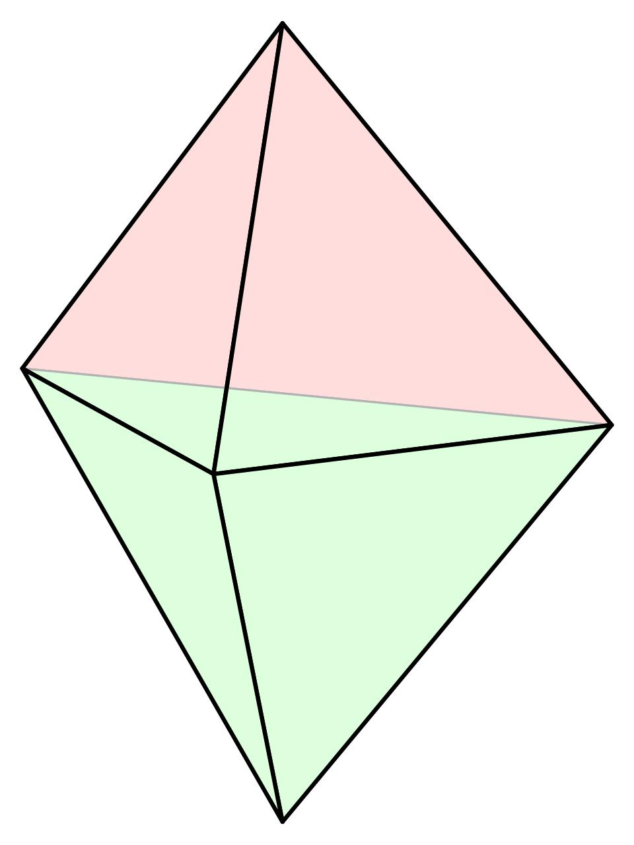

Geometric Structure
# Source: AI Source: Provided by: [Data Path: Persons Table -> ID Column: 1, Name_En Column: Motasem Essam] -> From: [ChatGPT] on [7/25/2026]
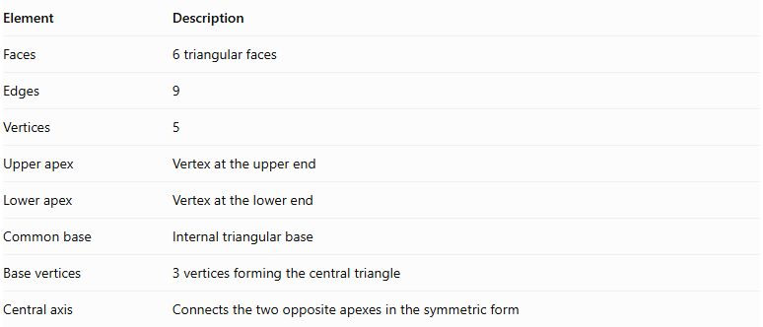
Element | Description
Faces | 6 triangular faces
Edges | 9
Vertices | 5
Upper apex | Vertex at the upper end
Lower apex | Vertex at the lower end
Common base | Internal triangular base
Base vertices | 3 vertices forming the central triangle
Central axis | Connects the two opposite apexes in the symmetric form
The common triangular base is an internal construction element and is not counted as an external face.

Face Structure
# Source: AI Source: Provided by: [Data Path: Persons Table -> ID Column: 1, Name_En Column: Motasem Essam] -> From: [ChatGPT] on [7/25/2026]
The triangular bipyramid has six external triangular faces.
They are divided into two groups:
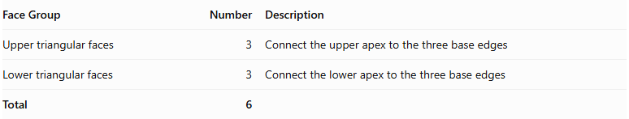
Face Group | Number | Description
Upper triangular faces | 3 | Connect the upper apex to the three base edges
Lower triangular faces | 3 | Connect the lower apex to the three base edges
Total | 6
Each external face is a triangle. In a regular triangular bipyramid, all six faces are equilateral triangles.

Edge Structure
# Source: AI Source: Provided by: [Data Path: Persons Table -> ID Column: 1, Name_En Column: Motasem Essam] -> From: [ChatGPT] on [7/25/2026]
The triangular bipyramid has nine edges:
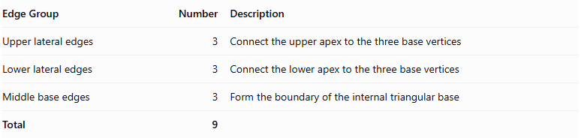
Edge Group | Number | Description
Upper lateral edges | 3 | Connect the upper apex to the three base vertices
Lower lateral edges | 3 | Connect the lower apex to the three base vertices
Middle base edges | 3 | Form the boundary of the internal triangular base
Total | 9

Vertex Structure
# Source: AI Source: Provided by: [Data Path: Persons Table -> ID Column: 1, Name_En Column: Motasem Essam] -> From: [ChatGPT] on [7/25/2026]
The triangular bipyramid has five vertices:
- 1 upper apex.
- 1 lower apex.
- 3 middle vertices forming the triangular base.
$$V=2+3=5$$
In the regular form:
- Three faces meet at each apex.
- Four faces meet at each middle vertex.

Mathematical Properties
# Source: AI Source: Provided by: [Data Path: Persons Table -> ID Column: 1, Name_En Column: Motasem Essam] -> From: [ChatGPT] on [7/25/2026]
For a triangular bipyramid:
$$n=3$$

A. Number of Faces
# Source: AI Source: Provided by: [Data Path: Persons Table -> ID Column: 1, Name_En Column: Motasem Essam] -> From: [ChatGPT] on [7/25/2026]
$$F=2n=2(3)=6$$

B. Number of Edges
# Source: AI Source: Provided by: [Data Path: Persons Table -> ID Column: 1, Name_En Column: Motasem Essam] -> From: [ChatGPT] on [7/25/2026]
$$E=3n=3(3)=9$$

C. Number of Vertices
# Source: AI Source: Provided by: [Data Path: Persons Table -> ID Column: 1, Name_En Column: Motasem Essam] -> From: [ChatGPT] on [7/25/2026]
$$V=n+2=3+2=5$$

D. Euler's Formula
# Source: AI Source: Provided by: [Data Path: Persons Table -> ID Column: 1, Name_En Column: Motasem Essam] -> From: [ChatGPT] on [7/25/2026]
$$V-E+F=2$$
$$5-9+6=2$$
<badge color="success">Verified</badge> Euler's formula is satisfied.

Surface Area and Volume
# Source: AI Source: Provided by: [Data Path: Persons Table -> ID Column: 1, Name_En Column: Motasem Essam] -> From: [ChatGPT] on [7/25/2026]
For a regular triangular bipyramid with equilateral triangular faces of side length $s$:

A. Surface Area
# Source: AI Source: Provided by: [Data Path: Persons Table -> ID Column: 1, Name_En Column: Motasem Essam] -> From: [ChatGPT] on [7/25/2026]
The area of one equilateral triangular face is:
$$A=\frac{\sqrt{3}}{4}s^{2}$$
Since there are six faces:
$$SA=6(\frac{\sqrt{3}}{4}s^{2})$$
$$\boxed{SA=\frac{3\sqrt{3}}{2}s^{2}}$$

B. Volume
# Source: AI Source: Provided by: [Data Path: Persons Table -> ID Column: 1, Name_En Column: Motasem Essam] -> From: [ChatGPT] on [7/25/2026]
For two congruent regular tetrahedra joined base-to-base, each tetrahedron has volume:
$$V_{tetrahedron}=\frac{s^{3}}{6\sqrt{2}}$$
Therefore:
$$V_{bipyramid}=2(\frac{s^{3}}{6\sqrt{2}})$$
$$\boxed{V=\frac{s^{3}}{3\sqrt{2}}}$$

Symmetry
# Source: AI Source: Provided by: [Data Path: Persons Table -> ID Column: 1, Name_En Column: Motasem Essam] -> From: [ChatGPT] on [7/25/2026]
A regular triangular bipyramid has:
- A threefold rotational symmetry axis.
- Three vertical reflection planes containing the central axis.
- A horizontal reflection plane through the common triangular base.
- Central inversion symmetry.
Its rotational symmetry axis passes through the two opposite apexes and the center of the common triangular base.

Relationship to Other Solids
# Source: AI Source: Provided by: [Data Path: Persons Table -> ID Column: 1, Name_En Column: Motasem Essam] -> From: [ChatGPT] on [7/25/2026]
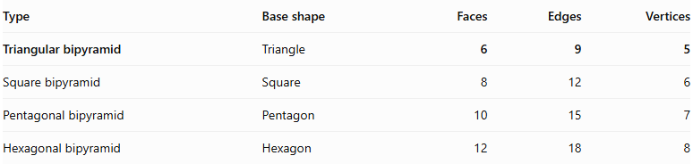
Type | Base shape | Faces | Edges | Vertices
Triangular bipyramid | Triangle | 6 | 9 | 5
Square bipyramid | Square | 8 | 12 | 6
Pentagonal bipyramid | Pentagon | 10 | 15 | 7
Hexagonal bipyramid | Hexagon | 12 | 18 | 8

Worked Examples
# Source: AI Source: Provided by: [Data Path: Persons Table -> ID Column: 1, Name_En Column: Motasem Essam] -> From: [ChatGPT] on [7/25/2026]
Example 1: Calculate the surface area of a regular triangular bipyramid.
Given:
$$s=4 cm$$
Using:
$$SA=\frac{3\sqrt{3}}{2}s^{2}$$
$$SA=\frac{3\sqrt{3}}{2}(4^{2})$$
$$\boxed{SA=24\sqrt{3}{ cm}^{2}}$$
Example 2: Calculate its volume.
Given:
$$s=3 cm$$
Using:
$$V=\frac{s^{3}}{3\sqrt{2}}$$
$$V=\frac{3^{3}}{3\sqrt{2}}$$
$$\boxed{V=\frac{9}{\sqrt{2}}{ cm}^{3}}$$

Constructing Triangular Bipyramid in Solid Geometry

Geometric Instruments Used
# Source: AI Source: Provided by: [Data Path: Persons Table -> ID Column: 1, Name_En Column: Motasem Essam] -> From: [ChatGPT] on [7/25/2026]
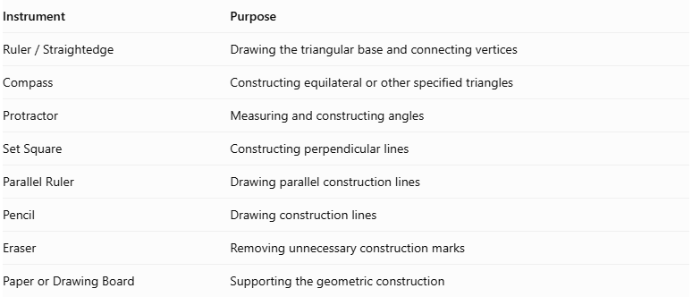
Instrument | Purpose
$$Ruler/Straightedge$$ | Drawing the triangular base and connecting vertices
Compass | Constructing equilateral or other specified triangles
Protractor | Measuring and constructing angles
Set Square | Constructing perpendicular lines
Parallel Ruler | Drawing parallel construction lines
Pencil | Drawing construction lines
Eraser | Removing unnecessary construction marks
Paper or Drawing Board | Supporting the geometric construction

Instrument-Based Construction Procedures

Constructing the Equatorial Triangle
# Source: AI Source: Provided by: [Data Path: Persons Table -> ID Column: 1, Name_En Column: Motasem Essam] -> From: [ChatGPT] on [7/25/2026]
- Determine the required dimensions of the equatorial triangle.
- Use a ruler and compass to construct the triangle.
- For an equilateral triangular base, construct three equal sides and three ${60}^{∘}$ interior angles.
- Mark the three vertices as $A$, $B$, and $C$.
- Draw the three equatorial edges $AB$, $BC$, and $CA$.

Locating the Two Apices
# Source: AI Source: Provided by: [Data Path: Persons Table -> ID Column: 1, Name_En Column: Motasem Essam] -> From: [ChatGPT] on [7/25/2026]
- Determine the intended positions of the upper and lower apices.
- Mark the upper apex as $P$.
- Mark the lower apex as $Q$.
- Position the two apices on opposite sides of the equatorial plane.
- For a symmetric bipyramid, position the apices at equal perpendicular distances from the equatorial plane.

Connecting the Upper Apex
# Source: AI Source: Provided by: [Data Path: Persons Table -> ID Column: 1, Name_En Column: Motasem Essam] -> From: [ChatGPT] on [7/25/2026]
- Use a ruler to connect $P$ to vertex $A$.
- Connect $P$ to vertex $B$.
- Connect $P$ to vertex $C$.
- These connections form three upper triangular faces:
- Triangle $PAB$
- Triangle $PBC$
- Triangle $PCA$

Connecting the Lower Apex
# Source: AI Source: Provided by: [Data Path: Persons Table -> ID Column: 1, Name_En Column: Motasem Essam] -> From: [ChatGPT] on [7/25/2026]
- Use a ruler to connect $Q$ to vertex $A$.
- Connect $Q$ to vertex $B$.
- Connect $Q$ to vertex $C$.
- These connections form three lower triangular faces:
- Triangle $QAB$
- Triangle $QBC$
- Triangle $QCA$

Completing the Triangular Bipyramid
# Source: AI Source: Provided by: [Data Path: Persons Table -> ID Column: 1, Name_En Column: Motasem Essam] -> From: [ChatGPT] on [7/25/2026]
- Draw all six external triangular faces.
- Identify the visible and hidden edges.
- Use solid lines for visible edges.
- Use dashed lines for hidden edges when necessary.
- Verify that the two triangular pyramids share the same equatorial triangle.
- Ensure that the shared triangular base is internal rather than an external face.

Constructing a Regular Triangular Bipyramid
# Source: AI Source: Provided by: [Data Path: Persons Table -> ID Column: 1, Name_En Column: Motasem Essam] -> From: [ChatGPT] on [7/25/2026]
- Construct an equilateral triangular equatorial base.
- Determine the required edge length.
- Position the two apices symmetrically on opposite sides of the equatorial plane.
- Make all six lateral edges equal to the equatorial edge length.
- Connect each apex to all three equatorial vertices.
- Verify that all six external faces are equilateral triangles.
The resulting solid is a regular octahedron.

Constructing a Triangular Bipyramid Using a Net
# Source: AI Source: Provided by: [Data Path: Persons Table -> ID Column: 1, Name_En Column: Motasem Essam] -> From: [ChatGPT] on [7/25/2026]
- Construct six triangular faces.
- Arrange the six triangles around the shared equatorial structure with correct edge matching.
- Ensure that each triangular face has the appropriate side lengths.
- Fold the triangles to form the upper and lower pyramidal portions.
- Join corresponding edges to complete the solid.

Key Points
# Source: AI Source: Provided by: [Data Path: Persons Table -> ID Column: 1, Name_En Column: Motasem Essam] -> From: [ChatGPT] on [7/25/2026]
- A triangular bipyramid consists of two triangular pyramids joined at a common base.
- It has 6 external triangular faces.
- It has 9 edges and 5 vertices.
- Its common triangular base is internal.
- Three faces meet at each apex.
- Four faces meet at each middle vertex.
- Its regular form has threefold rotational symmetry.
- Its regular form can be viewed as two regular tetrahedra joined base-to-base.

Conclusion
# Source: AI Source: Provided by: [Data Path: Persons Table -> ID Column: 1, Name_En Column: Motasem Essam] -> From: [ChatGPT] on [7/25/2026]
The Triangular Bipyramid is the simplest bipyramid, consisting of six triangular faces arranged around a central triangular region. It has five vertices, nine edges, and a threefold rotational symmetry axis in its regular symmetric form.
Classification note: A regular triangular bipyramid is not a Platonic solid because its vertices do not all have the same number of incident faces: three faces meet at each apex, while four meet at each middle vertex.

